Safety instructions  Read these operating instructions through carefully before using the equipment. Incorrect use may invalidate any warranty claims against Caijia technology co.,ltd.  Warnings & and safety limitations  Only wear the welding helmet if it is connected to the blower and the blower is in operation before entering the working area.  NOTE. The Caijia unit does not provide protection against gaseous substances. . Leave the working area immediately if:  The battery warning is triggered(Diagram 5 A red LED illuminates and audible signal is heard). Either recharge the  battery or replace it.  or  The air flow warning is triggered(Diagram 5 C red LED illuminates and audible signal is heard). Change the filter in a safe area.  A strong wind from the side or from behind may affect the protection provided by the helmet.  When removing the welding helmet, take all necessary precautionary measures to prevent breathing in dust or contaminated material that may have collected on the outside of the helmet.  Never immerse the blower or the battery in water; this could damage the unit. Ensure that no water  enters the unit when cleaning it.  Used filters cannot be cleaned or recycled. Attempts to clean the filters by using compressed air or water will damage them.  Never short-circuit the battery, this could cause fatal damage.  The PAPR may not be used, — in a flammable or explosive atmosphere, — if the inhaled air is lacking in oxygen (Europe: <17 %) or the concentration of toxins is so high that a protection class in excess of TH3P (Europe), — in temperatures below -5 °C or above +55 °C, — in surroundings where there is immediate danger to life and limb.  Make sure the connection hose is bent and not sucked into or blocked other objects in the area  Do not use in places under below situation strong wind appears, at very high work rates, at peak inhalation flow(because negative pressure is generated in the mask and external air flows in)  Do not use this product when air flow is below 170L/M, at that time, if warning is triggered(the PAPR master will vibrate and yellow/red light will filck together, then it will beep).please stop work and leave the working area.  Do not use with near power failure and no respiratory protection, these consider to be a  abnormal situation.  Do not use in case of power outages, as the co2 concertration inside the helmet may increase.  Do not connect the respirator filter directly to the helmet  When verifying the protection level of the product ensure that user does not confuse the  European standard EN12941 label with the label associated with other standards. | Warranty & Liability  Caijia Technology Co.,Ltd will repair the product or replace it where necessary in cases of materials or manufacturing defects arising within 12 months from the date of purchase, provided the product has been used in accordance with the authorized use as provided by the operating instructions. The warranty will be invalidated if:  The serial number has been altered, removed or rendered illegible.  The product has been intentionally damaged, misused, opened or modified. Non-original replacement parts are used or it is not properly serviced.  If the PPE is damaged or if it fails during the Pre-use inspection check points the PPE has to be removed from the use  The warranty only covers repairs or the replacement of defective parts. Under no circumstances does Caijia Technology Co.,Ltd undertake to provide any warranty for general breakdowns or consequential damage.  Area of application  The Caijia” is a powered air purifying respirator (PAPR) for protection against dust and particles. filters  contaminated air and blows it into the welding helmet hood  This system is TH3P certified in accordance with European standard EN12941: 1998/A 1:2004/A2:2008 TH3P The Caijia” is used to support the ventilation process, supplies clean air reducing the effort required to breathe. The electronic system for controlling the airflow monitors the blower in order to ensure a constant flow of min. 170 nI/min*. The effective operating time of the Caijia with a fully charged battery depends on the battery type and filter state (see technical specifications table).  Prior to pre-use inspection and testing  Carefully remove the packaging of the various parts.  Check whether the unit is complete in accordance with the scope of delivery and nothing has been damaged. If any damage is found or a part is missing, contact the sales department immediately. Never use a damaged or incomplete unit.  On delivery the battery is not fully charged. Charge the battery completely before first usage.  Pre-use inspection and testing  Before every use, ensure that the Caijia is in a faultless condition and proceed as follows:  1. Ensure that the master filter and the pre filter is properly installed and the cover is securely fitted (Cover has to close with a clicking sound).  2. Check the air hose and air connector for damage (holes, tears, cuts). Connect the air hose to the helmet and blower by inserting the male bayonet fitting into the female coupling and lock by twisting the fitting until it locks. Ensure that the male fittings have an 0-Ring seal in place. | 3 .Switch on the Caijia by pressing the on button for about 1 second. During the start up of around 3 seconds all 5 LED’s ( 2 LED’s in green for the flow level selection and 2 LED’s in red one is for battery  status and the other for blockage status and 1 yellow for filter change(Diagram 5 e))are switched on and an audible alarm (3 beeps) will sound. Afterwards the Caijia” is ready for use.  4.In addition, during this start up time the Caijia “performs an initial self-check to ensure that the unit delivers a correct flow above 170 I/min. If the red filter LED turns off after the before-mentioned 3 seconds, a flow of at least 170 I/min is maintained. Due to an in-built flow sensor the Caijia controls and continuously maintains a correct flow above 170 I/min during the entire operation.  5.As mentioned the Caijia” has a visible and audible warnings for low battery, blocked filter or reduced airflow. If a warning is triggered leave the working area immediately!  Periodically check the low airflow alarm to check its functionality. This test should be carried out with a fully charged battery and unblocked filter and hose in a clean area. To test the alarm switch the unit on disconnect the hose from the welding helmet and place the palm of the hand over hose. Within 15 seconds the alarm will sound and the red Air Flow LED will illuminate. Immediately remove your hand from the hose. The alarm will automatically switch off. Reconnect the hose to the helmet.  Mode of operation  Fitting and adjustment of Welding Helmet. Place helmet over the head and adjust the internal head  harness for comfort by:  A) Re locating the pins on the head top strap into the appropriate locating holes.  B) Pushing and rotating the knurled knob clockwise or anti clockwise on the head band until the required position is reached. Release the knob and the head band will be locked in place.  C)Put on the face seal and let the face inside of face seal, then tighten latch of lace to appropriate position. make sure face seal Is fit into face and lower jaw  Adjusting the belt Size: Put the belt on and adjust the size so that the blower unit sits  comfortably on your hips/waist.  Installing the battery: The battery has to be inserted and clipped into the locating slot on the  bottom right side of the Focus Air. Slide and push the battery until a click is heard.  Removing and charging the battery: ess the retaining button on the bottom left side and  pull it out until it is completely removed from the blower unit.  Connect the battery to the charger. The charging process is signalled by the yellow illuminated LED on the charger. After charging has been completed, the LED turns green and the trickle charging mode is activated.  Flow adjustment: The blower has two air flow levels: 170 and220 nl/min*. To change the air flow level press the on button until your requested air flow level is reached.  Master filter and pre filter replacement: in case of a filter alarm indication please replace the pre filter. Please monitor the time between filter alarms. As for every pre filter replacement this time period is expected to become shorter. If you feel the replacement interval becomes too short, which is at user’s discretion, you are then recommended to replace the master filter and the pre filter.

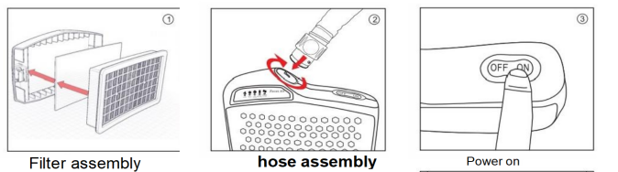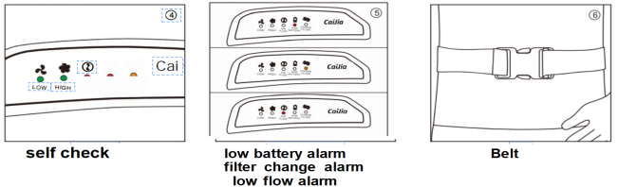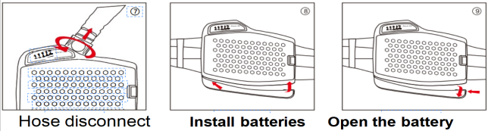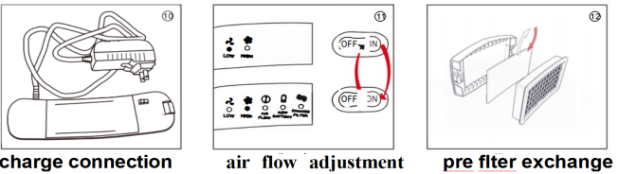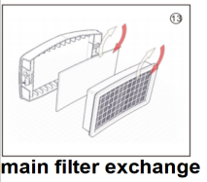  Troubleshooting :Blower does not start.  Make sure the battery is installed correctly and the battery is fully charged  Filter warning is on(Diagram 5B) even when main filter and pre filter have been properly  installed.  Check with your supplying distributor  Battery running time becomes very short.  Defective charger or battery. Replace and dispose of the used battery in accordance with the national regulations for special waste.  Maintenance: Check the Welding Helmet regularly in accordance with the enclosed Operating InstructionS. Check the face seal and the air nozzle for holes, cracks or other damage and check that they are correctly positioned on the helmet (see operating instructions). Do not use the system until all worn or damaged parts have been replaced.  Maintenance Programme  Cleaning and disinfection: After each use. Visual inspection: Before and after each use.  If the unit is in storage the battery must be recharged every 4 months.  Cleaning: Using a clean cloth moistened with soapy water, clean the blower, the air hose and the safety helmet. Leave the unit to dry at room temperature. Do not use strong detergents, solvents, alcohol or cleaning agents containing abrasives. The face seal is washable (hand wash, do not spin).Not wash the | alcohol or cleaning agents containing abrasives. The face seal is washable (hand wash, do not spin).Not wash the filter and that no water enter into the blower  Storage: The Caijia system and its accessories must be stored in a dry place . Rec Of tittle Folded storage temperature range -5 °C to +25 ”C. storage Humidity:<90% Protect from sunlight, hydrocarbons and solvent vapour.  Recommended Operating Temperature -5° C - +50° C(23°F- +131°F), Operating  Relative Humidity:<90%  Disposal. Please dispose in accordance with the national regulations for  special waste NOT with normal household waste.  Technical specifications: (we reserve the right to make technical changes) Nominal protection  factor TH3P R SL classification (Europe).  Blower unit Flow rates: Level 1: min. 170 l/min * Level 2: min. 220 l/min*.  * At standard conditions: 20° C, 0 meters above sea level (1013 hPa) all Levels controlled.  Material PC+ABS  Blower High quality ball bearing long life brush less motor Fuse Electronic fuse  Battery Type  Standard Long Life Type: Li-ion rechargeable  Voltage / capacity: 14.8V / 2.2Ah Charging cycles: > 500  Operating time level 1* 10 h  Operating time level 2*6h30  Charging time: approx. 2.5h  Weight: 288g  Colour: black  *min operating time is with a fully charged new battery and filter at room temperature. Noise level Max. 67 dB(A)  Warning signals optical and audible alarm for low power, clogged filter and reduced air flow. Master Filter type P3 TH3P R SL for TH3P system (Europe)  Air hose Length: 850 mm (900mm including connectors) with protective sleeve. Diameter: 31 mm  (inside).  Colour: black/grey.  Weight 1097g (incl. Filter and battery). Dimensions LxWxH: 224x190x70 mm (Max).  Standards s hou Id read EN 12941 : 1998/A1 : 2003/A2: 2008 T H 3P R SL ,  Spare parts (see labels on units).  1Master filter TH3P R SL filter for TH3P system (Europe) CJ 0008 2 Pre filter CJ 0010  - Spark protector CJ0011  - Standard battery (Li-Ion 37Wh) CJ0005 .  - Belt with shoulder straps CJ0007  - CAIJIA PAPR CJ0004  - Air Hose for complete with protective sleeve CJ0009 8 Ca i Jia Series Welding Helmet CJ00017/18/19 | CE Notif!ed Body 0082  APAVE SUDEUROPE SAS (n°0082) CS60193 13322 MARSEILLE Cedex 16 Franœ  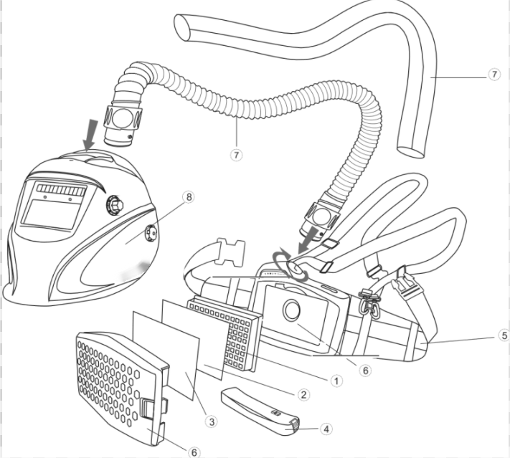  Declares that the new PPE described hereafter in conformity with the provisions of Council  Regulation 2016/425 standard No EN12941:1998/A1:2003/A2:2008 is indentical to the PPE which is the subject of EU type examination certificate of conforrmity.issued by APAVE EXPLOITATION FRANCE SAS - 6 Rue du Général Audran 92412 Courbevoie cedex – France:  In charge of production control  Chose module:D  Notified Body’s number: CE1024  Notified Body name:Vyzkumny Ustav Bezpecnosti Prace,v.v.i  Notified Body’s address: Jeruzalemska 9 116 52 PRAHA 1 Country: Czech Republic

