

**AICELLE Display**

**is sense and simplicity**

**SINCE 1993**

**龙凤芯，自然光，更健康**

**AICELLE Display Systems,**

**Natural Light for Healthy Lif**e

**powered air-purifying respirat**or

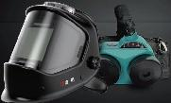FA400

Merak A天璇

Innovative power

comprehensive protection

★ EN 12941:1998+A1:2003+A2:2008 TH2 PR SL



★ Effective protection against

breathing,eyes and skin.

★ Designed to enhance comfort.

★ The loose-fit head mask does not

require a fit test,which is more

convenient and effective.

**Auto-darkening welding Helmet**

Ultra clear large window wider horizons

★ Easy to operate,comfortable and lightweight.

★ Various ADF options are available.

★Moderate strength shell,high

toughness and strong impact resistance.

★ All-round eye and face welding protection.

★ UV/IR protection class DIN16.

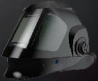



 C

富 相

**Phecda A 天玑**

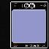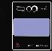

**ADF**

**ADF0001 ADF0002**

**Technical parameter**

|  |  |  |
| --- | --- | --- |
| Model | ADF0001 | ADF0002 |
| Viewing Area | 98*87mm | 98*89mm |
| CE Optical Class | 1/1/1/2 | 1/1/1/2 |
| Arc Sensors | 4PCS | 4PCS |
| Sensitivity | Stepless Variable(Internal) | 1-6 levels digital control |
| Switch Time(23℃) | <1/30000S | <1/30000S |
| Delay Time | 0.1-1.0s Stepless Variable | 0.1-1.0s digital control |
| Power Supply | Solar Cell,1*CR2450 Li-Battery Change Required | Solar Cell,1*CR2450 Li-Battery Change Required |
| Shade Control | Stepless Variable(Internal) | Internal(digital) |
| Shade State | DIN4/5-8/9-13 | DIN4/5-8/9-13 |
| Operating Temp | -10℃~+60℃ | -10℃~+60℃ |

一、Dust filter box SE0003,Mars net+HEPA.

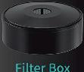● Conforms to EN12941 TH2P standard.

● Filtration efficiency>99.98%.



● The spark catcher screen reduces the

contact of sparks and other hot materials

with the filter cotton.

二、Composite filter cartridge SE0009, Mars net+activated carbon+HEPA.

● Conforms to EN 12941 TH2A1P standard.

● Protection against dust,

filtration efficiency>99.98%.

● Odor removal,smoke odor.

●Protection against organic gases/vapors.

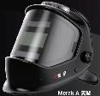

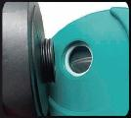

Thread connection:EN148 thread440mmX1/7"



Li**thium Battery**

一 、Capacity 2600mAh standard battery

● Maximum range of 10 hours

(New filter cartridge and fully charged state).

● Lithium batteries are charged without memory effect. Charging status can be easily pulled out.

二、Capacity 3000mAh high capacity battery

● Maximum range of 12 hours

(New filter cartridge and fully charged state).

● Lithium batteries are charged without memory effect. Charging status can be easily pulled out.

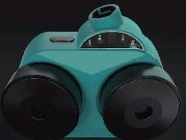

ON OFF mn 点 r

N

ON

Tap to power on,tap to select after power on High air flow or low air flow.

OFF

Press and hold for2 seconds to turn off the machine.

Y Low-speed air flow

LOW Provides a steady airflow of 180L/min.

High-grade air flow

HIGH Provides a stable airflow of 220L/min.

Low airflow alarm



AIR

FLOW



When the airflow is low,the AlR FLOW light of the machine will light up,sounding an alarm and accompanied by

vibration,the user should leave the workplace immediately and go to a safe area to check the machine.

LOWWhen the battery power is low,the machine LOWBATTERY BATTERY light comes on and An alarm sounds and vibrates.

口 Low battery alarm

The user should leave the workplace immediately and go to a safe area to replace or recharge the battery.

Filter cartridge replacement



CHANGE When the filter cartridge is severely clogged and the

FILTER machine's CHANGE FILTER light comes on,the user should

replace the cartridge with a new one as soon as possible.



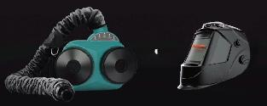十

临

富 相

Dubhe A天枢

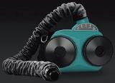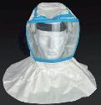

十

Wide range of applications

With respirator as the core,by equipping with welding cap and hood to create a variety of combination solutions to meet the needs of various industries.

201mm

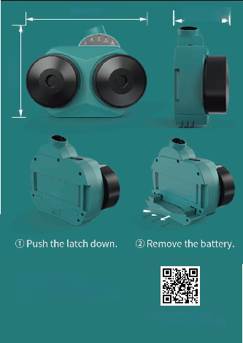

247mm 105mm

J



the latch down.

深圳市龙凤芯科技有限公司

地址：深圳市宝安区西乡铁仔路凤凰智谷A509

服务电话：4001-897-687

官网：<http://www.aicelle.com>

<http://www.aicelledisplay.com>

② Remove the battery.

①Push